

**DEPARTMENT OF COMPUTER SCIENCE**

**FORMAN CHRISTIAN COLLEGE**

**(A Chartered University)**

**LAHORE, PAKISTAN**

**COMP 213 (B)**

**Final Project**

**Title: Gol-Gappay Stall Management System**

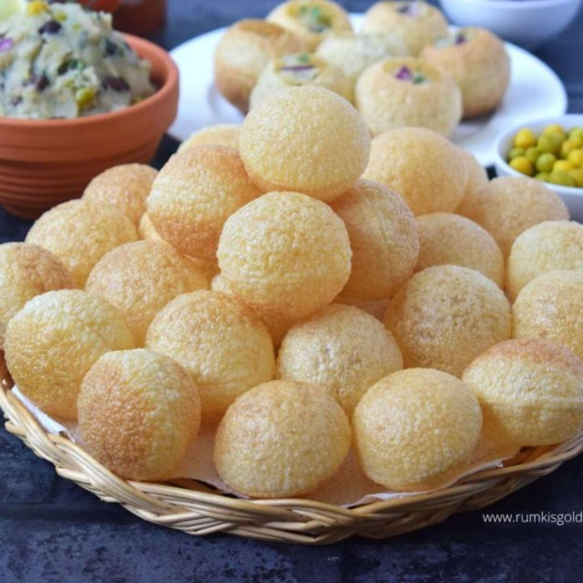

**Submitted to: Ma’am Asma Basharat**

**Group Members**

Abdullah Mehtab (241607845)

Ali Abdul Aziz (241560709)

Faizan Imtiaz Cheema (241605093)

**Context Diagram:**

Main systems included are: -

1. Stall Management
2. Stock/Storage Management
3. Transport Management
4. Employee Management
5. Locations Schedule Management
6. Sales Management (for large scale events)
7. Furniture/Utensils Management
8. Customer Service Management

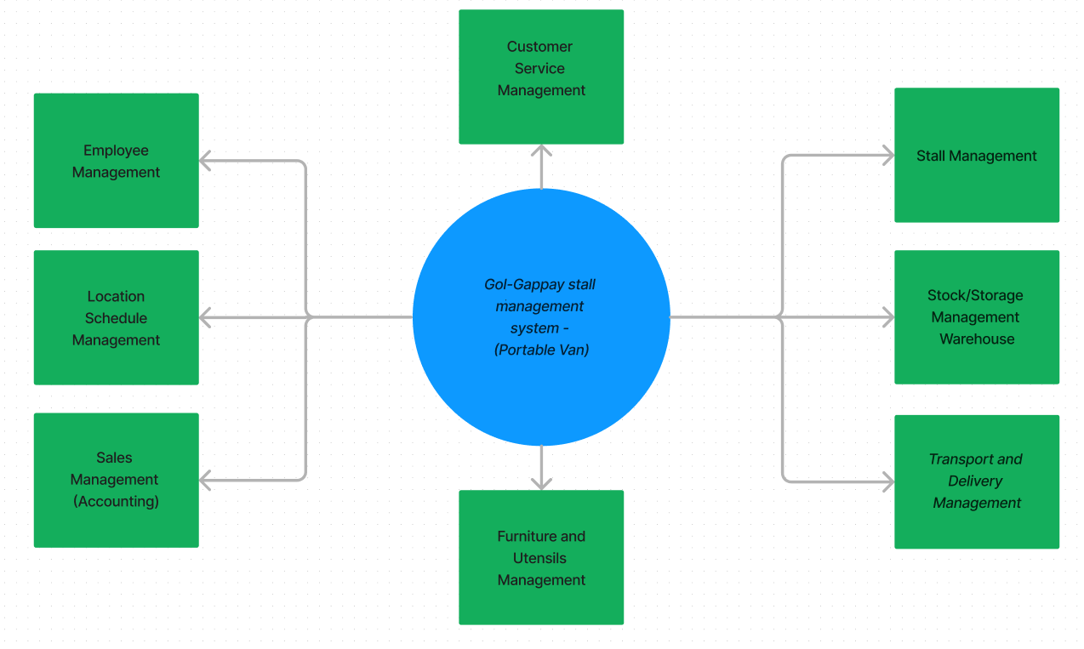

**Functional Requirements:**Our database stores all information regarding our Gol-Gappay stall system, in which there are proper stalls on specific locations throughout. The requirements are.

1. Stalls:

* Must do their base task, serve the customers with what they require.
* Must be clean and appealing (decorations)
* Must have a proper portable sitting place.
* As an alternative to sitting and dine, packaging must be an option per stall.
* Each stall has a unique ID, starting and ending time, specifying the locations.

1. Stock Warehouse:

* Must be stocked with the ingredients required by the stalls.
* Must be prepared before the stock runs out.
* Have transport ready in case any stall requires stock.
* Stock must be stored in a safe and reserved way.
* The stalls must be located at an ideal distance from the warehouse.
* Each warehouse has its Unique ID, with its city location, street address and postal code.

1. Transport and Delivery:

* Transport must be swift and quick, but most importantly safe.
* Transportation of stalls to locations must be through vans.
* Transportation of stock to warehouse must be through vans.
* Delivery to customers through transport-bikes
* There must be back-up transport in case of emergency.
* Each vehicle has its unique ID, license plate, fuel cap and specified vehicle type

1. Employee Management

* Employees managing the stalls must know how to do so.
* They must know how to put together a dish and serve.
* They must be patient with customers.
* They must be easy to deal with for customers.
* Each employee has their Unique ID, first name and last name with a check if they have an health certificate or not.

1. Location Management

* Locations with an ideal distance from the warehouse must be selected.
* The location should preferably be a public place with areas where people wait for something (like near a train station, bus station, outside institutions) etc.
* There must be a permit in those said locations.
* The locations are linked with where the stalls are set up using Stall-ID

1. Furniture, Utensils, and decoration Management  
   - There must be clean and durable furniture for customers to sit on

- There must be clean packaging system

- There must be clean utensils available for customers to use

- There must be appealing decorations for stalls such as:  
lights during night, variety of colors used, good looking banners

- Each Accessory has its own true false value to show if they exist in this specified stall or not depending on stall id and furniture id.

- Each Furniture set has its own Unique ID and its set is linked with one another

1. Sales Management (Accounting):

- There must be a record of every sale that’s made

- There must be a manager to overlook Salary of Employees, Price of Stock and

Furniture, Rent of Stalls and Warehouses, Profit/Loss from Sales

* Each Sale has its expenses with daily profit/loss.

1. Food Management

* There Must be a health certificate for the food served.
* There must be clean water with every serving.
* Each Order is ID-ed with an Order number and other items which were included in the order.

**Entity Relationship Diagram**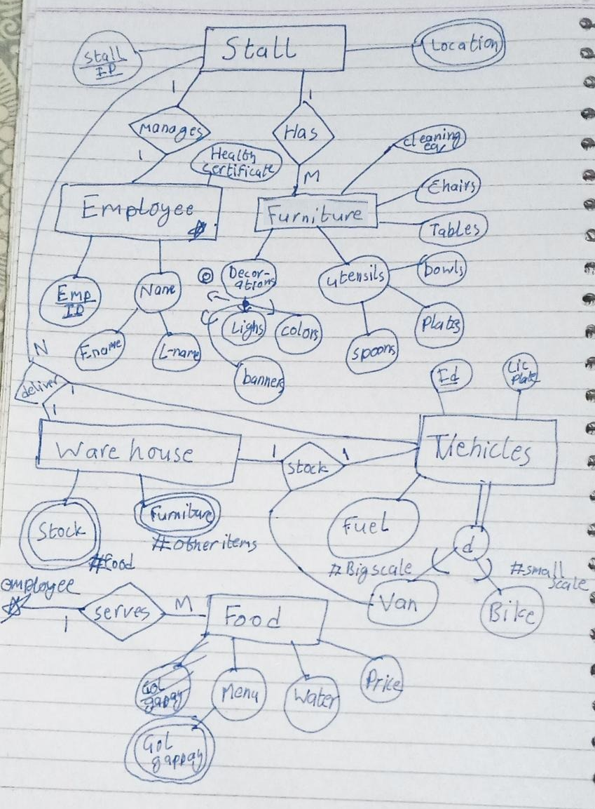

**Enhanced Entity Relationship Diagram**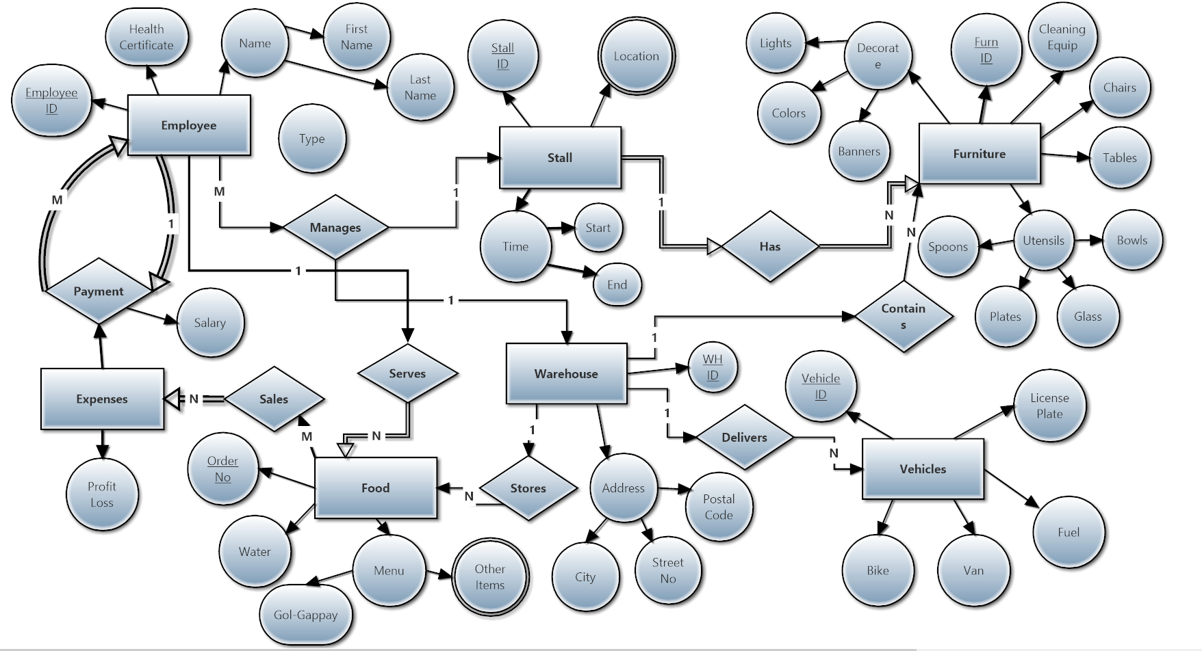

**Entities:**

Employee, Stall, Furniture, Expenses, Food, Warehouse, Vehicles

**Relationships:**

Payment, Manages, Has, Contains, Sales, Serves, Delivers, Stores

**All Possible Tables (Relational Model):**

**Entity Tables:**

|  |  |  |  |  |  |  |
| --- | --- | --- | --- | --- | --- | --- |
| Tables | Name | PRIMARY KEY | Other- |  |  |  |
| Table-1 | Employee | Employee ID | First Name | Last Name | Health Certificate | Type |
| Table-2 | Stall | Stall ID | Start Time | End Time | Locations (Multi) |  |
| Table-2a | Locations | Stall ID | (street) |  |  |  |
| Table-3 | Furniture | Furn ID | Lights | Colours | Banners | Cleaning Equip |
| continue- | Chairs | Tables | Spoons | Plates | Glass | Bowls |
| Table-4 | Expenses |  | Profit/Loss |  |  |  |
| Table-5 | Food | Order No | Water | Gol-Gappay | Other Items |  |
| Table-5a | Other Items | Order No |  |  |  |  |
| Table-6 | Warehouse | WH ID | City | Street No | Postal Code |  |
| Table-7 | Vehicles | Vehicle ID | License plt | Fuel | Bike | Van |

**Relation Tables:**

|  |  |  |  |  |  |
| --- | --- | --- | --- | --- | --- |
| Tables | Name | PRIMARY KEY |  |  |  |
| Table-1 | Emp - Manages - Stall, WH | Employee ID | Stall ID | WH ID | Vehicle ID |
| Table-2 | Emp - Pays - Emp | Employee ID | Salary | Type |  |
| Table-3 | Food - Sales - Expenses | Order No | Profit/Loss |  |  |
| Table-4 | Emp - Serves - Food | Employee ID | Order No | Water | Menu |
| Table-5 | WH - Stores - Food | WH ID | Order No |  |  |
| Table-6 | WH - Delivers - Vehicles | WH ID | Vehicle ID | Employee ID |  |
| Table-7 | WH - Contains - Furniture | WH ID | Furn ID |  |  |
| Table-8 | Stall - Has - Furniture | Stall ID | Furn ID | Decoration | Utensils |

**Identify dependencies for tables.**

**Table-1 (Employee):** Employee ID, First Name, Last Name, Health Certificate, Type

**{**Emp ID} -> {First Name}  
 {Emp ID} -> {Last Name}  
 {Emp ID} -> {Health Cert}

{Emp ID} -> {Type}

{First Name, Last Name, Health Cert, Type} -> {Emp ID}

**Table-2 (Stall):** Stall ID, Start Time, End Time

{Stall ID} -> {Start Time}

{Stall ID} -> {End Time}

{Start Time, End Time} -> {Stall ID}

**Table-2a:** Locations, Stall ID

{Stall ID} -> {Locations}

{Locations} -> {Stall ID}

**Table-3:** Furn ID, Lights, Colour, Banners, Cleaning Equip, Chairs, Tables, Spoons, Plates,

Glass, Bowls

{Furn ID} -> Lights

{Furn ID} -> Colors

{Furn ID} -> Banners

{Furn ID} -> Chairs

{Furn ID} -> Tables

{Furn ID} -> Spoons

{Furn ID} -> Plates

{Furn ID} -> Glass

{Lights, Colour, Banners, Cleaning Equip, Chairs, Tables, Spoons, Plates, Glass, Bowls} -> {Furn ID}

**Table-4 (Warehouse):** WH ID, City, Street No, Postal Code

{WH ID} -> {City}

{WH ID} -> {Street No}

{WH ID} -> {Postal Code}

{City, Street No, Postal Code} -> {WH ID}

**Table-5 (Vehicle):** Vehicle ID, License plate, Fuel, Bike, Van

{Vehicle ID} -> {Fuel}

{Vehicle ID} -> {License plate}

{Vehicle ID} -> {Bike}

{Vehicle ID} -> {Van}

{License plate, Fuel, Bike, Van} -> {Vehicle ID}

**Table-6 (Managing): E**mployee, Stall, Warehouse, Vehicle

{Employee} -> {Stall}

{Employee} -> {Warehouse}

{Employee} -> {Vehicle}

{Stall, Warehouse, Vehicle} -> {Employee}

**Table-8 (Delivery):** Warehouse , Vehicle , Employee

{Employee} -> {Warehouse}

{Employee} -> {Vehicle}

{Warehouse, Vehicle} -> {Employee}

**Table-9 (Contains):** Warehouse, Furniture

{Warehouse} -> {Furniture}

{Furniture} -> {Warehouse}

**Table-10 (has):** Stall, Furniture, Decoration, Utensils

{Stall} -> {Furniture}

{Stall} -> {Decoration}

{Stall} -> {Utensils}

{Furniture, Decoration, Utensils} -> {Stall}

**Normalization**

1NF: There are no multivalued attributes in our tables.

2NF: There is only 1 key attribute in our table and all other attributes depend on it.

3NF: There is no candidate key in our system, so the tables remain the same.

BCNF: There are no tables with multiple primary keys

**All tables with finalized data:**

1. Employee  
   Table

   Description automatically generated with medium confidence
2. Stall  
   Table, Excel

   Description automatically generated
3. Stall Managers per stall  
   Chart

   Description automatically generated
4. Stall Locations  
   Table

   Description automatically generated with low confidence
5. Furniture  
   Table

   Description automatically generated with medium confidence
6. Warehouse  
   Graphical user interface, application

   Description automatically generated
7. Vehicle driven by Employee  
   Table

   Description automatically generated with medium confidence
8. Vehicle  
   Graphical user interface, application, table, Excel

   Description automatically generated
9. Payment  
   Table

   Description automatically generated with medium confidence
10. Stall’s assigned furniture **Table

    Description automatically generated with low confidence**

**Queries)**

1. Displaying all Employee Names who have the health certificate and are stall managers  
   Graphical user interface, application, Word

   Description automatically generated
2. Display the ID and License plates of all delivery vehicles ordered by their fuel capacity in descending order  
   A picture containing text

   Description automatically generated
3. Display 3 Employees who have the letter 'e' in their first name  
   Graphical user interface, text, application

   Description automatically generated
4. Display the first names of all Employees who have salary under 15000  
   Graphical user interface, application, Word

   Description automatically generated
5. Display the ID and end timings of the stalls which start at 12:00PM, then update those timings by fixing their end time to 7:00PM, and Display again  
   Graphical user interface, text, application, email

   Description automatically generated
6. Display the names and ids of drivers and vehicles who hav drive BIKES for Delivery  
   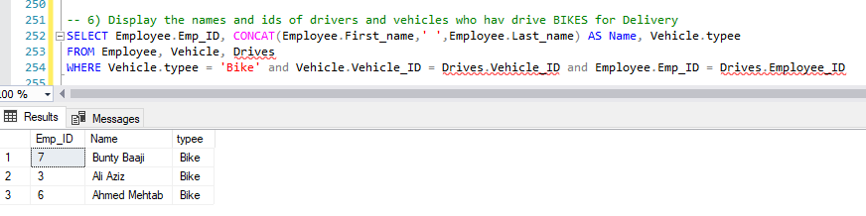
7. Display furniture information of the stalls which end at 7:00pm  
   A screenshot of a computer

   Description automatically generated with medium confidence
8. Display Average Salary of the employees and the name of the employee with highest salary  
   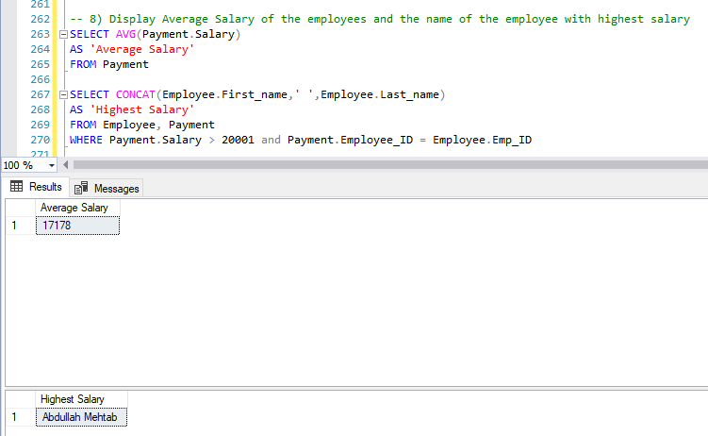
9. Select Distinct furniture selection where there are lights available  
   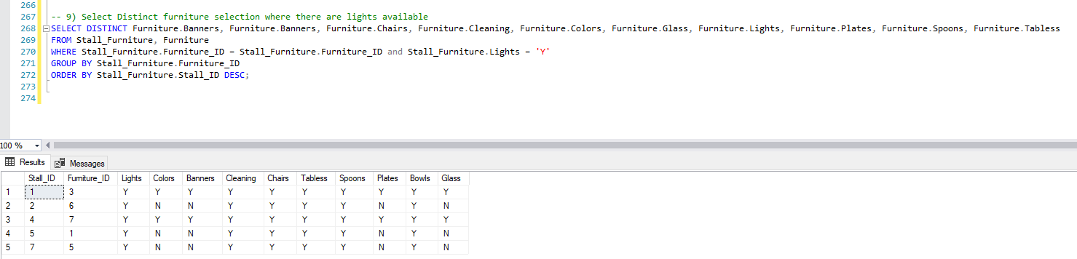
10. Create View and Make "Omer Sajid" the manager of the Gol-Gappay Management Stall System

**Transactions:**

**First Transaction-**

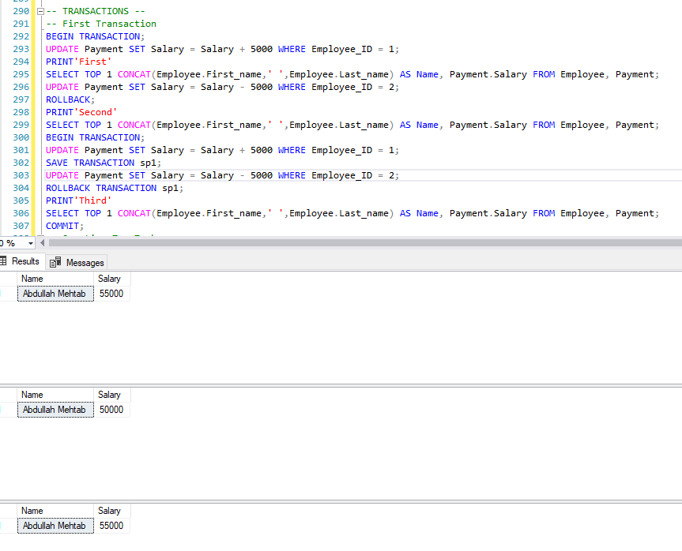

**Second Transaction-  
**